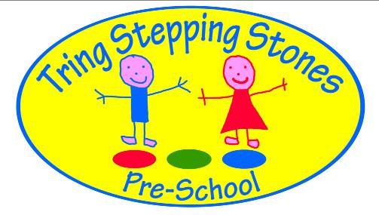

Tring Stepping Stones Pre-School Waiting list Application Form

`
Name of Child:

Date of Birth:

Parents’ name:

Address:

Post code:

Telephone:

Email address:

Preferred days that I would like my Child to attend Pre-School.

Monday Tuesday Wednesday Thursday Friday

A registration fee of £20 is payable on your accepting a place for your child at Pre-School to cover administration costs. This will secure your place at pre-school and your child will be given a bag and polo shirt when they start.

We offer two sessions as your child starts Pre-School. Additional sessions after they are settled are normally available. We endeavour to increase this to the full 5 sessions once your child is funded (subject to availability).

If we no longer need the place, we will inform Pre-School as soon as possible.

`
Signature of parent: Date:

